Git practice
Create login html fie by using visual code
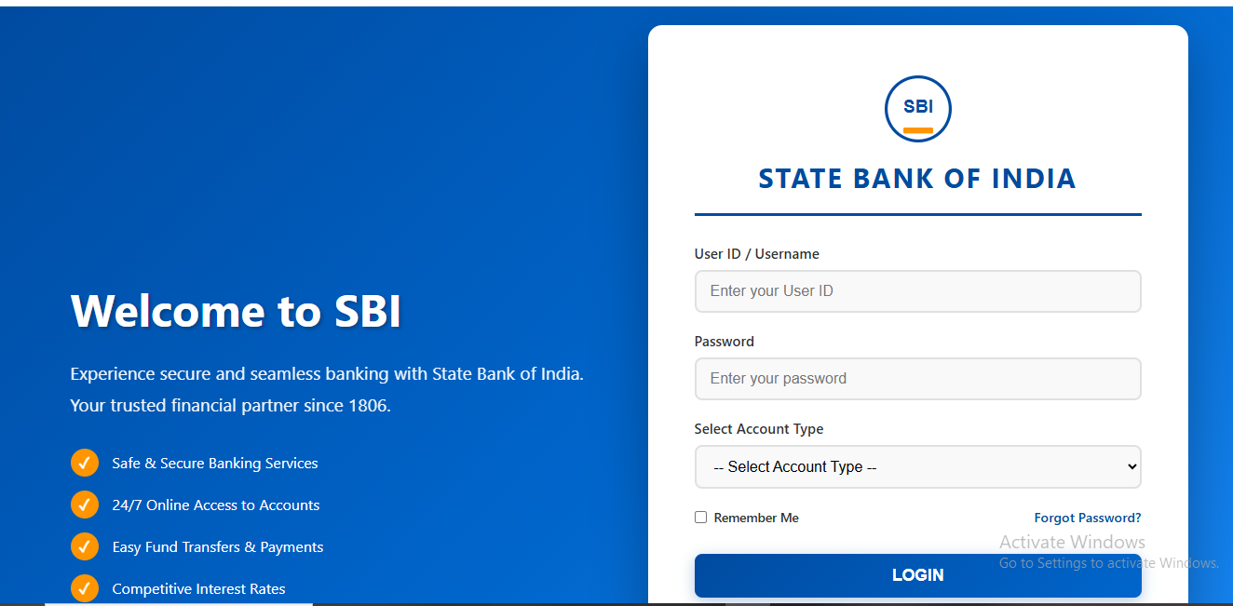

57 touch login.html
58 git init
59 git add .
60 git status
61 git commit -m "commiting login file"
62 git remote add origin https://github.com/srinilelladevops/Demo2.git
63 git push origin master
64 gitpush origin -u master
65 git push -u master
66 git push -u origin master
67 git branch
68 cat login.html
69 git checkout -b srinivas
70 ll
71 ll
72 cat login.html
73 git checkout master
74 ll
75 cat login.html
76 history

Creating Branch and merge to master :
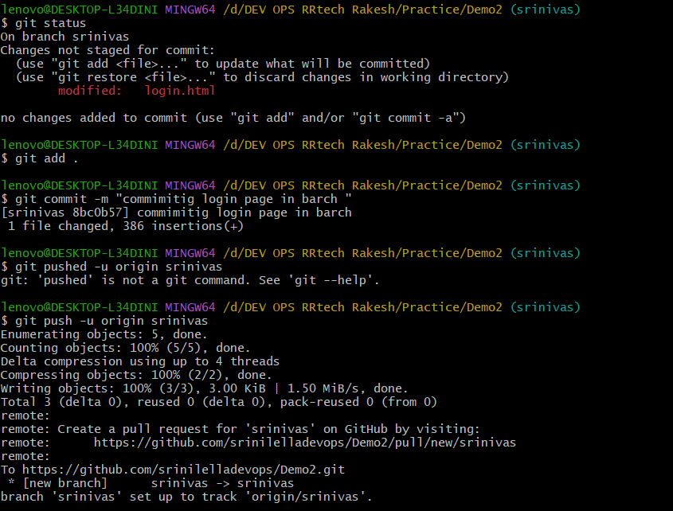

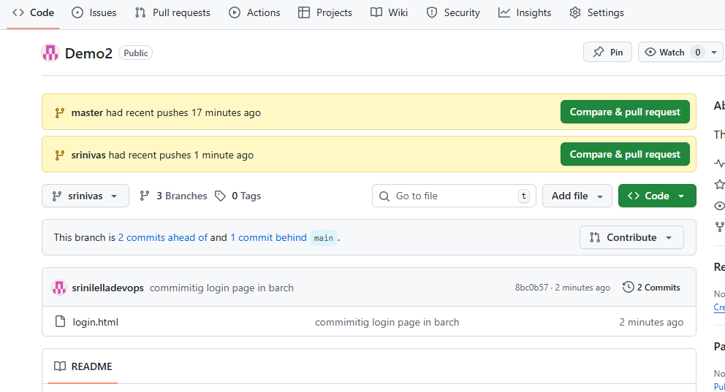
Merging to master
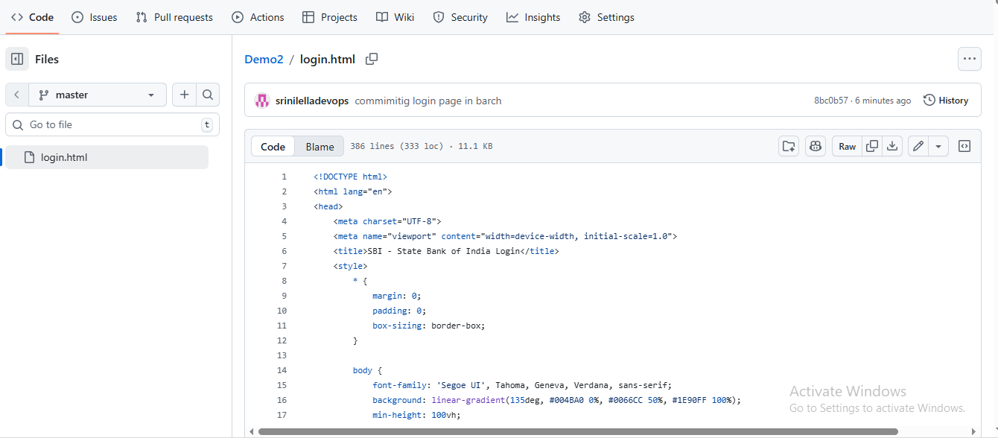

Merge data in in local system by using fetch & pull in git bash
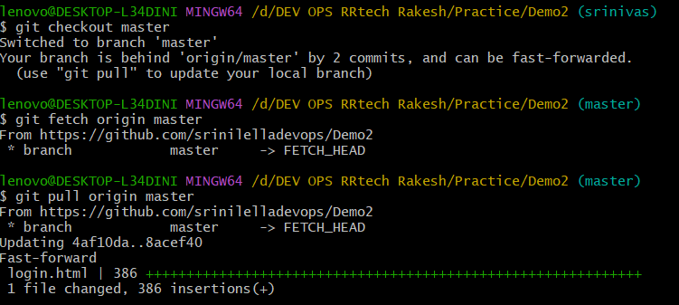

Adding tags
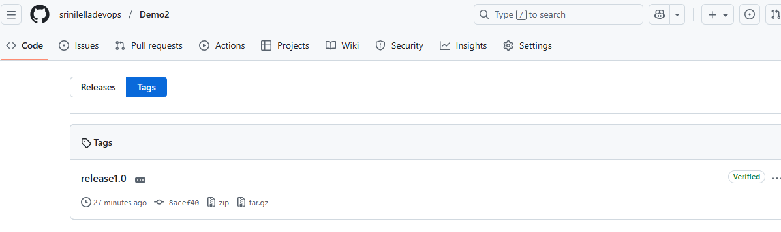
Cloneing:
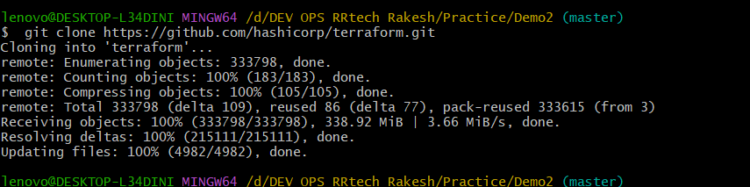

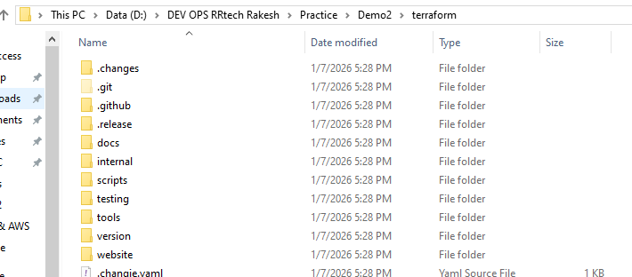

Git log & show :
